28.22: a) 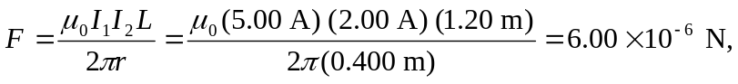 and the force is repulsive since the currents are in opposite directions.
b) Doubling the currents makes the force increase by a factor of four to 